* Task:
* Write PowerShell script to auto delete downloaded files current day to last modified date more than 15 days. By using Task Scheduler every 4hr run PowerShell script and delete the files

1. Create one folder in Download folder like name ‘Auto Delete’

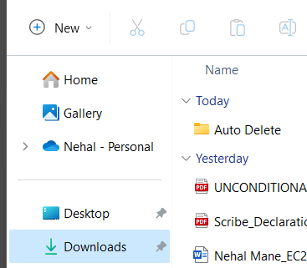

1. Open Chrome Browser > Settings > Downloads





1. Change the path click on change button to ‘Auto Deleted’ folder which we are created in Downloads folder

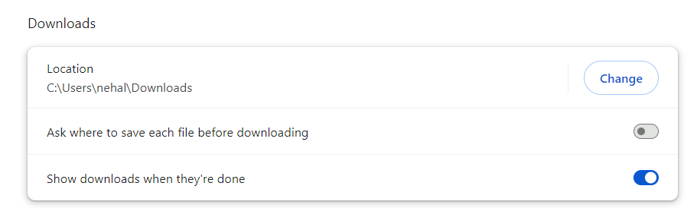

1. Open windows PowerShell ISE for writing script

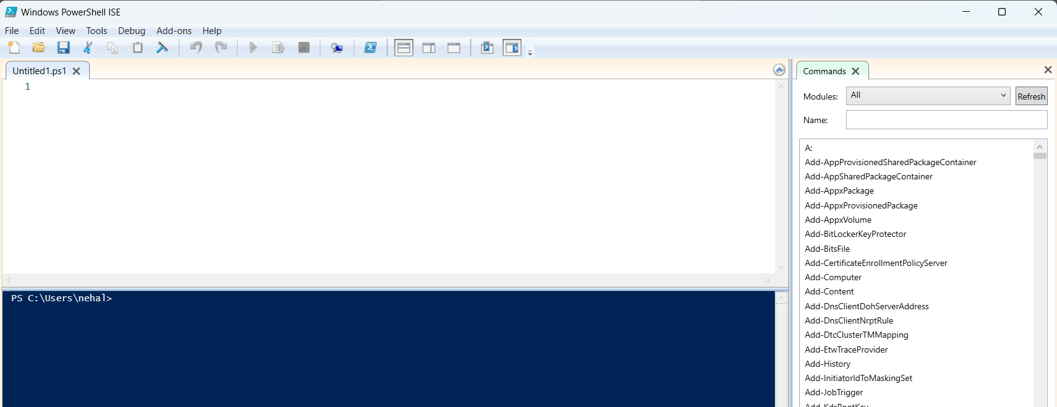

1. After running this Script, delete download files current date to last modified date more then 15 days

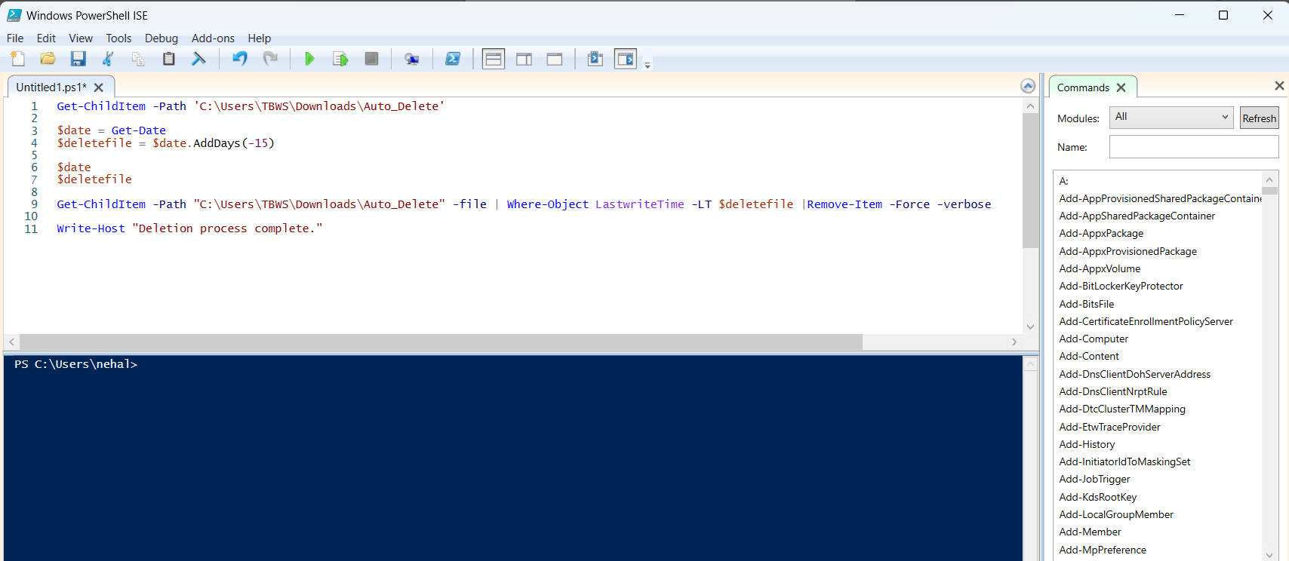

1. Now In our Windows open ‘Task Scheduler’ and click on ‘Create Task’

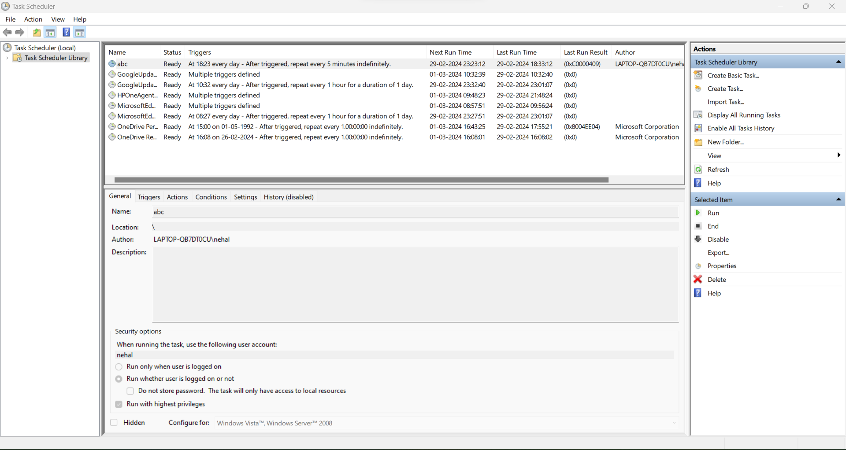

1. In General tab enter name for the task and check other fields

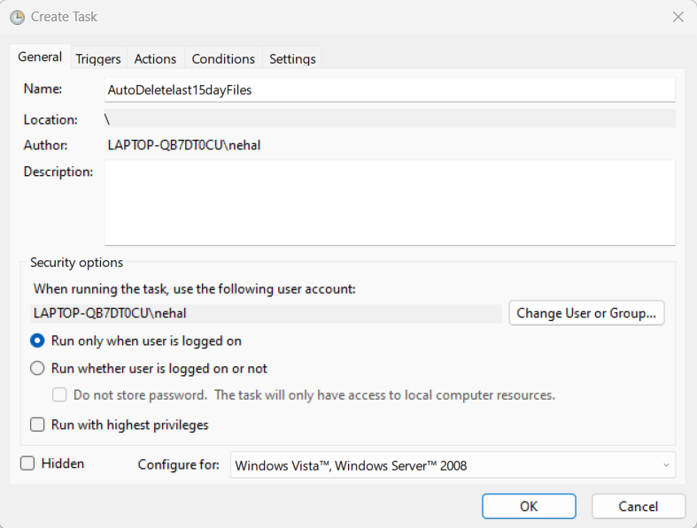

1. After that go to ‘Triggers’ tab > new > select date, time, repeat task every 4hr and then click on OK

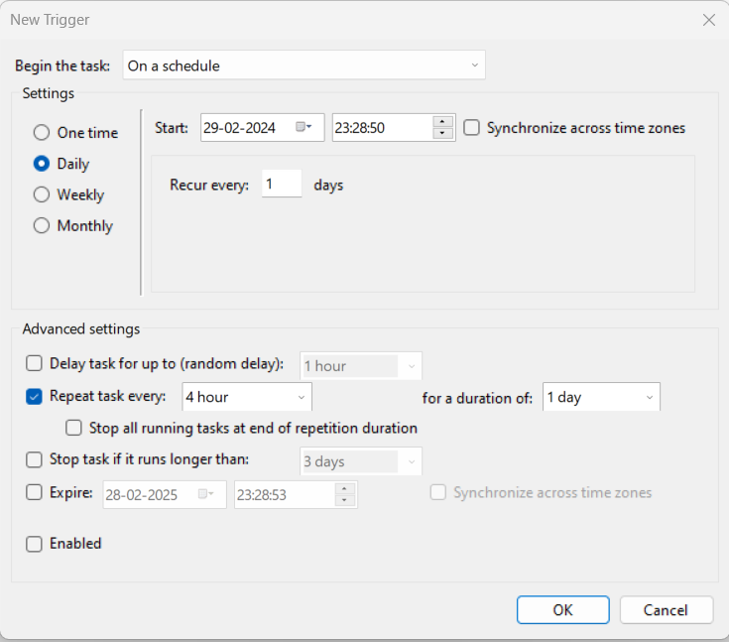

1. Then after go to
2. 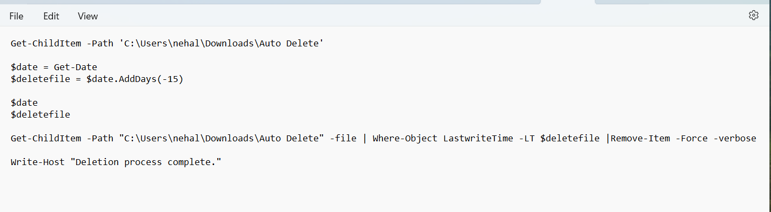
3. 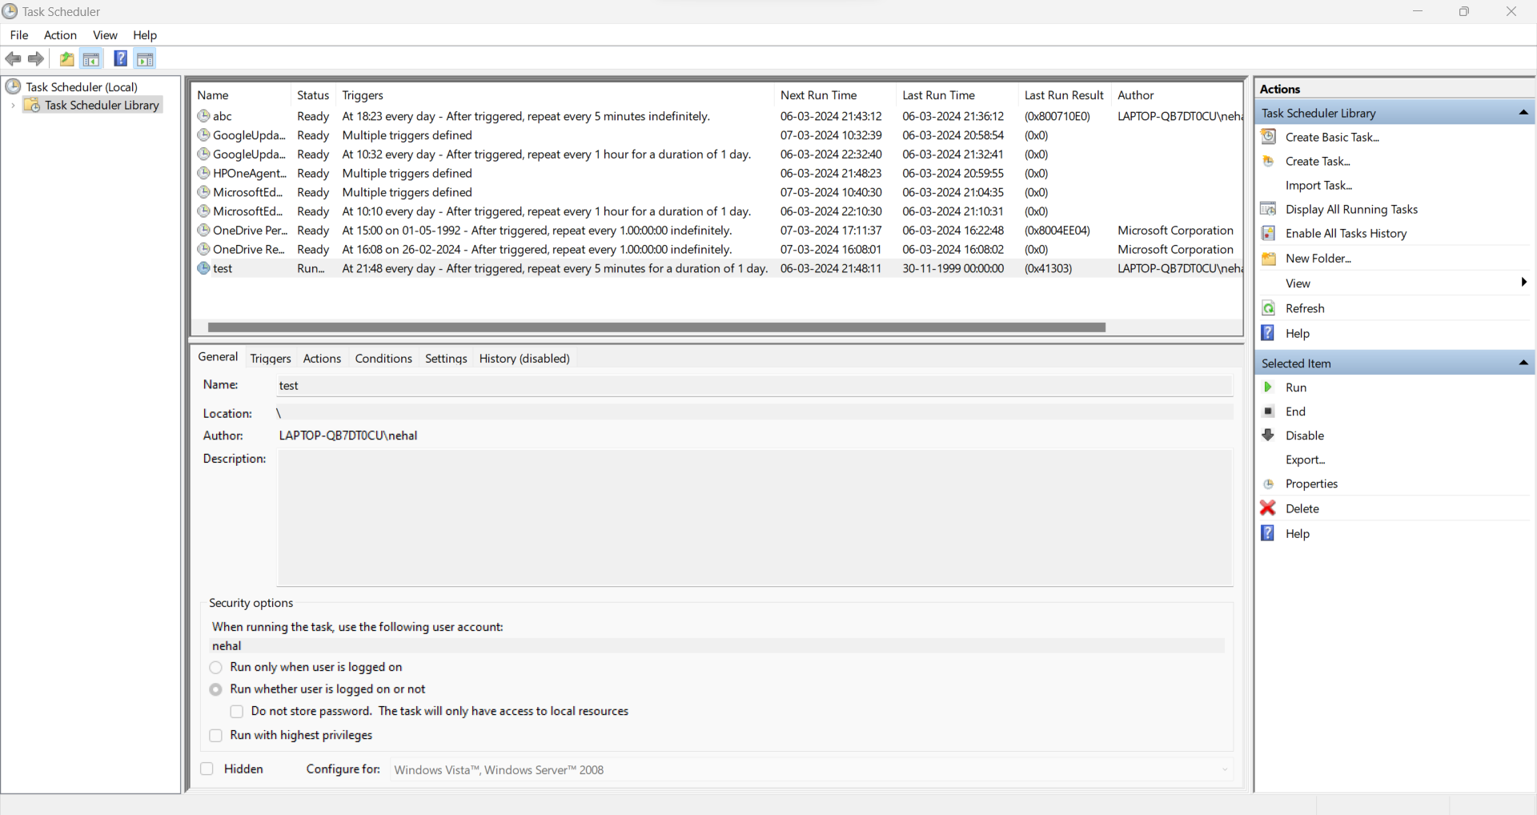
4. 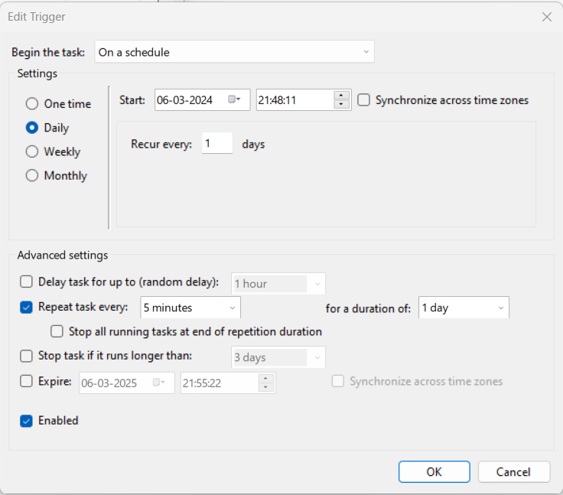
5. 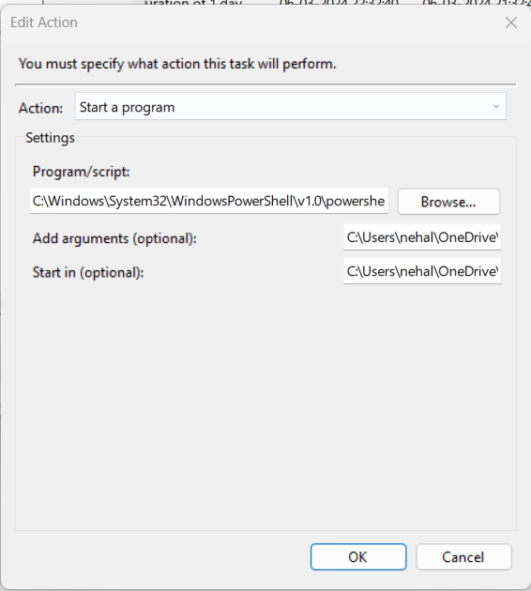
6. 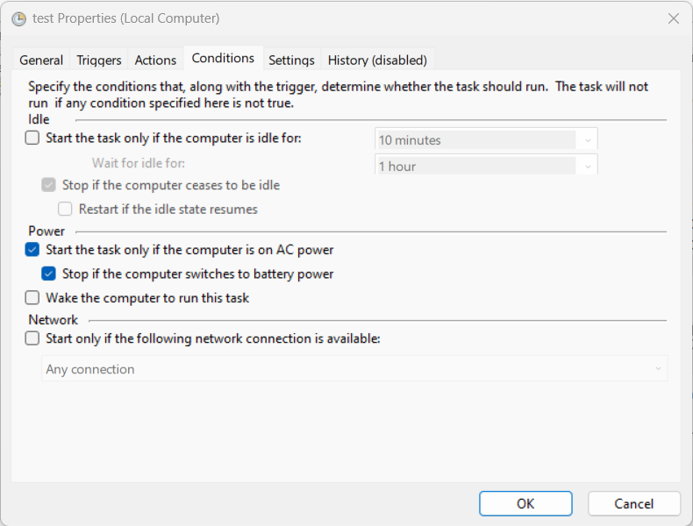
7. 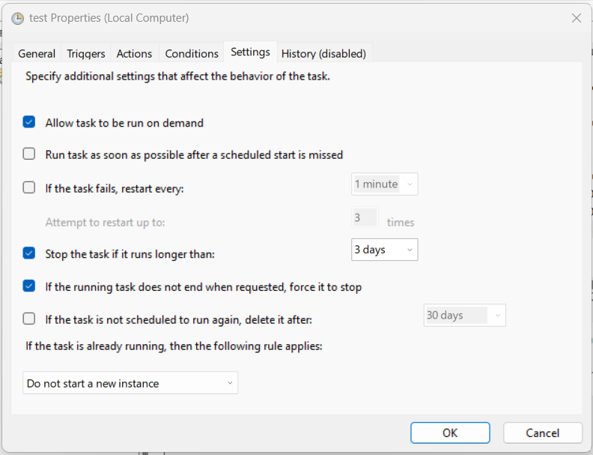
8. 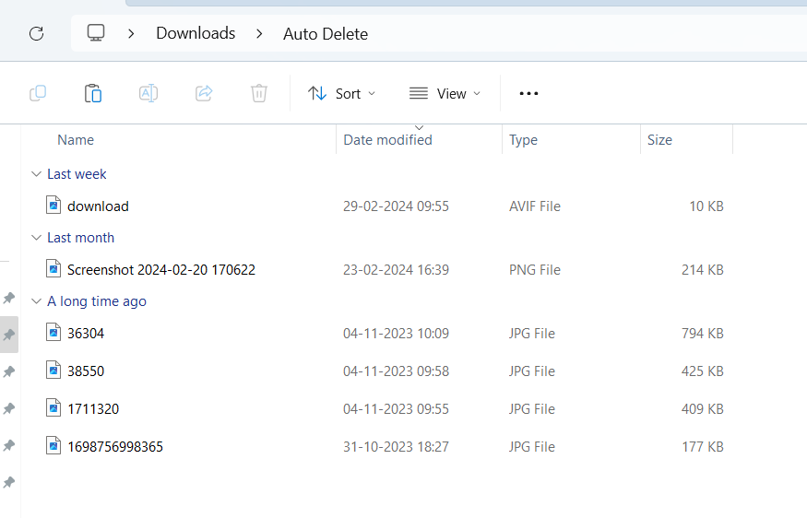
9. 